Software Requirements Specification

for

CS 441

Version 3.4.0

CSUSM

Fall, 2014

Gold Iguanas

December 8th, 2014

Table of Contents

1. Introduction i

1.1 Purpose i

1.2 Document Conventions i

1.3 Intended Audience and Reading Suggestions i

1.4 Project Scope i

1.5 References ii

2. Overall Description iii

2.1 Product Perspective iii

2.2 Product Features iii

2.3 User Classes and Characteristics iii

2.4 Operating Environment iii

2.5 Design and Implementation Constraints iii

2.6 User Documentation iii

2.7 Assumptions and Dependencies iii

3. System Features iv

3.1 Expense Data Entry iv

3.1.1 Users shall be able to record expenses iv

3.1.2 Stimulus/Response Sequences iv

3.1.3 Functional Requirements iv

3.2 Expense Reports iv

3.2.1 Users shall be able to view totals v

3.2.2 Stimulus/Response Sequences v

3.2.3 Functional Requirements v

3.3 User Report **Error! Bookmark not defined.**

3.3.1 Admin users shall be able to view user activity **Error! Bookmark not defined.**

3.3.2 Stimulus/Response Sequences **Error! Bookmark not defined.**

3.3.3 Functional Requirements **Error! Bookmark not defined.**

3.4 User Designation iv

3.4.1 Users shall be able to identify themselves to the system iv

3.4.2 Stimulus/Response Sequences iv

3.4.3 Functional Requirements iv

4. System Design ix

5. Interface Requirements xi

5.1 User Interfaces xxvi

5.2 Hardware Interfaces xxviii

5.3 Software Interfaces xxviii

5.4 Performance Requirements xxviii

5.5 Safety Requirements xxviii

5.6 Security Requirements xxviii

5.7 Software Quality Attributes xxviii

6. Other Requirements xxviii

7. Approval xxix

7.1 Phase 1 xxix

7.2 Phase 2 xxix

7.3 Phase 3 xxx

8. Appendix A: Glossary xxx

9. Appendix B: Use Case Documentation xxxi

10. Appendix C: Issues List xxxiii

Revision History

|  |  |  |  |
| --- | --- | --- | --- |
| **Name** | **Date** | **Reason For Changes** | **Version** |
| RL Fletcher | 8/25/2014 | Initial Release | 1.0 |
| Ranier Limpiado/ Augustin Garcia | 9/26/2014 | Added signatures and new requirements | 1.1 |
| Ranier Limpiado | 9/27/2014 | Added UML, Screenshots, Use case descriptions | 1.2 |
| Ranier Limpiado | 9/30/2014 | Fixed Use case descriptions | 1.4 on sharepoint |
| Ranier Limpiado | 9/30/2014 | Added a few things for use case 7 | 1.4.1 |
| Augustin Garcia | 9/30/2014 | New screenshots for release 1.3.1 | 1.4.2 |
| Ranier Limpiado | 10/2/2014 | New UML diagram, Use case titles, and new Pseudo code under UML diagram | 1.4.3 |
| Ranier Limpiado | 10/2/2014 | Added use cases 8,9,10 | 1.5 |
| Ranier Limpiado | 10/5/2014 | Added goals to Use cases 9 and 10. Updated the screenshots for the UI. Fixed requirement 16. | 1.5.1 |
| Ranier Limpiado | 10/5/2014 | Fixed one last thing on use case 7. Added the version on the first page. | 1.5.2 |
| Ranier Limpiado | 10/5/14 | Cleaned up mistakes in View report use case and use case 5.  Got rid of empty date exceptions since they are never empty for use cases that use dates. | 1.5.3 |
| Jeff Henry | 10/18/2014 | Cycle Two Starts  Added new requirements and added titles to the screenshots from cycle one. | 2.1.1 |
| Jeff Henry | 10/22/2014 | Added Use Cases 1-7 | 2.1.2 |
| Jeff Henry | 10/22/2014 | Fixed some missing exceptions in the use cases  Added Use Case 8  Added requirement C2-REQ-38ex | 2.1.3 |
| Karan Singh | 10/31/2014 | Added Use Cases 8-10  New Naming Scheme Implemented  Fixed/Updated UML Diagram  Edited REQ 18 and 19  SRS formatting (Editing Notes and App name) | 2.1.4 |
| Jeff Henry | 11/5/2014 | Add new UI screenshots | 2.1.5 |
| Karan Singh | 11/6/2014 | Implemented Naming Scheme expanded  Added UI requirements to Screenshots | 2.1.6 |
| Maxwell Partington | 11/15/14 | Added appropriate sections for requirements.  Updated Use Cases  Added new requiremnets | 3.0.0 |
| Maxwell Partington | 11/15/14 | Fixed a couple of errors in requirements. | 3.1.0 |
| Maxwell Partington | 11/22/14 | Updated Use Case error messages. Added more requirements. | 3.2.0 |
| Maxwell Partington | 11/30/14 | Updated exception flows and fixed minor errors. Added requirements , updated use cases, added use cases. | 3.3.0 |
| Maxwell Partington | 11/30/14 | Fixed minor errors with numbering. | 3.3.1 |
| Maxwell Partington | 12/8/14 | Final SRS. | 3.4.0 |

# Introduction

## Purpose

This Software Requirements Document (referred to as SRS) defines the scope of the of the CS 441 Software Project for Fall 2014. (Hereafter referred to as Venture Business Management)

## Document Conventions

All Requirements designated as beloware to be tested

**A-REQ-#** will refer to Administrator Requirements.

**R-REQ-#** will refer to Reporting Requirements.

**E-REQ-#** will refer to Data Entry Requirements.

**U-REQ-#** will refer to User Requirements.

**S-REQ-#** will refer to System behavior Requirements.

**UI-HOME-REQ-#** will refer to all Home form related UI requirements.

**UI-ADMIN-REQ-#** will refer to admin only related UI requirements.

***UI-LOGIN-REQ-#*** *will refer to the Login form related UI requirements.*

***UI-ENTRY-REQ-#*** *will refer to the Expense Entry form related UI requirements.*

***UI-SUCCESS-REQ-****# will refer to the Success popup related UI requirements.*

***UI-REPORTS-REQ-#*** *will refer to the View Reports form related UI requirements.*

***UI-HISTORY-REQ-#*** *will refer to the View History form related UI requirements.*

***UI-ADDU-REQ-#*** *will refer to the Add User form related UI requirements.*

***UI-EDITU-REQ-#*** *will refer to the Edit User form related UI requirements.*

***UI-AECAT-REQ-****# will refer to the Add/Edit Category form related UI requirements.*

***UI-HELP- REQ-****# will refer to the Help form related UI requirements.*

***UI-ABOUT-REQ-****# will refer to the About form related UI requirements.*

***UI-BACKUP-REQ-#*** *will refer to the Backup form related UI requirements.*

***UI-RESTORE-REQ-#*** *will refer to the Restore form related UI requirements.*

***UI-MENU-REQ-#*** *will**refer to the Menu tab related UI requirements.*

***UI-ACTLOG-REQ-#*** *will refer to the Activity Log form related UI requirements.*

***UI-CHPASS-REQ-#*** *will refer to the Change Password form related UI requirements.*

## Intended Audience and Reading Suggestions

The SRS is to be used by Testers, Programmers and Analysts. Only Analysts will modify the document. The SRS is organized to give an overview of Venture Business Management, followed by specifics and then covers other related requirements. It is recommended that all readers read the entire document. Testers and Programmers should pay special attention to the System Features section. Testers will use the Functional Requirements section as a starting point for their test cases.

## Project Scope

Venture Business Management will be a small-business management system. The project will be divided into three phases.

For the first phase Venture Business Management will allow end-users to enter data and view reports based on the information entered. Venture Business Management will allow for Administrators who will have options unavailable to other employees.

During the second phase, Venture Business Management will have a finalized UI design. Additionally, administrators will be able to add users, edit users, add categories, edit categories and delete categories. Finally, an option to export the employee's data from the program will be implemented.

In the third phase, Venture Business Management will be enriched with a backup and restore feature so that the employee may recover any lost data. An activity log will be added to check on all employee activity. Lastly, the storage of the data will be designed as to allow an archiving of data via separate files and folders for potential user archives to be implemented later.

## References

The document, "**Project.PDF"**, defines the overall goals of the Software project and can be found at <http://cc.csusm.edu>.

# Overall Description

## Product Perspective

Venture Business Management is a new, self-contained product. It is not part of any larger system.

## Product Features

Venture Business Management is a stand-alone system for recording and reporting business expenses. The details of the product and its features are provided in Section 3.

## User Classes and Characteristics

The Software's actors will be an Administrator or an Employee. An Administrator can act as an Employee. This document will refer to Employee as the primary actor of the application when describing the flow of the application. This document will use the title Administrator when only an Administrator of the application can use the administrator features.

## Operating Environment

The Software is designed to run on Windows 7 and Windows 8 platforms.

## Design and Implementation Constraints

The Software will be delivered as an executable, written in C# using Microsoft Visual Studio.

## User Documentation

Teams will provide a user manual, which includes screen shots and explanations of the software use. The Analyst(s) will create the manual.

## Assumptions and Dependencies

*None.*

# System Features

## Employee Identification

### Employees are to identify themselves to the application

High Priority Item

Venture Business Management provides a means for an Employee to identify themselves to the application.

### Stimulus/Response Sequences

Once identified, Venture Business Management will display the last “login” date for an Employee, as well as the appropriate tab for their authority level. Administrators will see the "View Reports" tab, and Employees will see the "Enter Expense" tab.

### Functional Requirements

***U-REQ-1:*** *An Employee can enter their username of the format:*

*[0-9][a-z][A-Z].*

***U-REQ-2:*** *The Employee can enter their password corresponding to their account.*

***U-REQ-3:*** *The Employee can enter a password of the format [0-9][a-z][A-Z].*

***S-REQ-1****: Venture Business Management allows one user at a time to identify him/her self.*

***S****-****REQ-2:*** *If an Employee attempts to enter a false password 8 times, their account will be locked.*

## Expense Data Entry

### Employees are to record expenses into the application.

High Priority Item

Venture Business Management provides a means for an Employee to enter business expenditures.

### Stimulus/Response Sequences

Once an Employee is identified, Venture Business Management provides a means to enter expenditures via the "Enter Expense" tab. Expenses are to be associated with a category, date, and optionally comments about the expense.

### Functional Requirements

***E-REQ-1****: An Employee can enter expense amounts that are values from 1.00-99999.99 in dollar amounts.*

***E-REQ-2:*** *Each expense is associated with one category.*

***E-REQ-3****: Each expense is associated with a date of the format: mm/dd/yyyy.*

***E-REQ-4****:  Expenses are entered in dollars and cents for all categories except mileage.*

***E-REQ-5:*** *Expenses shall be a decimal number for mileage in the range of '1.0-999.9'.*

**E-REQ-6:** An Employee can optionally enter comments associated with the expense entries.

**S-REQ-3:** The application does not limit the amount of characters allowed for comments.

**S-REQ-4:** The application allows for copying and pasting of comments into the "Comments" textbox.

***S-REQ-5:*** *The application allows for copying and pasting of expenditures into the "Enter Expenditure" textbox.*

***S-REQ-6:*** *The application does not allow more numbers in any part of the"Enter Expenditure" textbox after a "." and two numbers after the "." have been entered.*

***S-REQ-7:*** *The "Enter Expenditure" textbox allows up to 9 numbers. This includes anything after "." that has been entered previously.*

***S-REQ-8:*** *The application allows one date per expenditure between the dates: 1/1/1753 and the current date.*

## Expense Reports

### Employees are to be able to view totals of expenses

High Priority Item

Venture Business Management provides a means for an Employee to view all expense data associated with their own account, with separate totals for both 'Mileage' and all other expenses.

### Stimulus/Response Sequences

Once an Employee is identified, Venture Business Management provides a means to view all expenses for an Employee designated time frame.

### Functional Requirements

***R-REQ-1:*** *An Employee can request a report of one of the expense categories.*

***R-REQ-2:*** *An Employee can request a report of all of the expenses for all categories.*

***R-REQ-3:*** *An Employee can request a detailed report of one of the expense categories.*

***R-REQ-4:*** *An Employee can request a detailed report of all of the expenses for all categories.*

***R-REQ-5:*** *An Employee can designate a time frame for viewing expense entry history for both a single category report, and all categories report.*

***R-REQ-6:*** *An Employee shall be able to export a copy of their reports to PDF.*

**R-REQ-7:** An Employee can sort their generated report via the columns:

"Date", "Expense", "Category", "Submitted By", "Comments".

***R-REQ-8:*** *An Administrator can view a history of expense entries for any or all Employees for an administrator designated timeframe.*

***S-REQ-9:*** *The application allows reports to be viewed between the dates:*

*1/1/1753 and the current date.*

## View History

### Administrators shall be able to view Employee expense activity

High Priority Item

Venture Business Management shall provide a means for an Administrator to view on-screen all historical data entry activity.

### Stimulus/Response Sequences

Once an Administrator is identified, Venture Business Management provides a means for an Administrator to view history of data entry activity.

### Functional Requirements

***A-REQ-1:*** *An Administrator can view a history of expense entries for any (or all) Employees for timeframe the administrator designates.*

**A-REQ-2:** An Administrator can sort expense information with the given

columns: "Date", "Expense", "Category", "Submitted By",

"Comments".

***S-REQ-10:*** *The application allows history of expense entries to be viewed*

*between the dates: 1/1/1753 and the current date.*

## Activity Log

### Administrators shall be able to view Employee application activity.

High Priority Item

Venture Business Management provides a means for an Administrator to all application activity for a given day.

### Stimulus/Response Sequences

Once the Administrator is identified, Venture Business Management provides a means for an Administrator to view a history of application activity.

### Functional Requirements

***A-REQ-3:*** *An Administrator can view a history of all Employee application activity for all Employees for a given day.*

## Administration

### Administrators are able to edit various aspects of the application.

High Priority Item

Venture Business Management provides a means for an Administrator to edit/add Employees, edit/add Categories.

### Stimulus/Response Sequences

Once the Administrator is identified, Venture Business Management provides a means for an Administrator to edit/add employees, and edit/add Categories.

### Functional Requirements

***A-REQ-4:*** *An Administrator can add a new Employee or Administrator to the application.*

**A-REQ-5:** Creating new user accounts will require the following information:

Username ( >5 Characters, of the format: [0-9][a-z][A-Z][ _ ])

First Name (>1 Characters, of the format: [a-z][A-Z][-'])

Last Name (>1 Characters, of the form:at: [a-z][A-Z][-'])

Password (>6 characters of the format [0-9][a-z][A-Z])

Email (Optional)

***A-REQ-6:*** *An Administrator can edit an existing Employee's Administrator capability.*

***A-REQ-7:*** *An Administrator can lock or unlock an existing Employee/Administrator account.*

***A-REQ-8:*** *An Administrator can delete an existing Employee/Administrator.*

***A-REQ-9:*** *An Administrator can change an existing Employee/Administrator's password.*

***A-REQ-10:*** *An Administrator can add a new Category to the application as long as that Category does not exist in the application already.*

***A-REQ-11:*** *A new category must be of the format: [a-z][A-Z]*

***A-REQ-12:*** *An Administrator can edit an existing Category's name as long as that Category is not a Government mandated IRS Category.*

***A-REQ-13:*** *An Administrator can delete a Category from the application as long as that Category is not a Government mandated IRS Category.*

## Backup/Restore

### Employees are able to backup and restore their data to and from a storage device.

High Priority Item

Venture Business Management shall provide a means for an Employee to backup and restore their data to and from a storage device.

### Stimulus/Response Sequences

Once the user is identified, Venture Business Management provides a means for an Employee to backup and restore their data to and from a storage device.

### Functional Requirements

***U-REQ-4:*** *An Employee can backup their data to a specified storage device or location.*

***U-REQ-5:*** *An Employee can restore their data from a specified storage device or location that contains and existing backup.*

## Forgot Password

### Employees are able to have their password reset.

High Priority Item

Venture Business Management shall provide a means for an Employee to notify an Administrator to reset the Employees password.

### Stimulus/Response Sequences

Once the Employee opens the application, selecting the 'Forgot Password' option on the "Login" screen will allow them to notify an Administrator that the Employee has forgotten their password.

### Functional Requirements

***U-REQ-6:*** *An employee can select the "Forgot Password" option on the "Login" screen.*

***S-REQ-11:*** *The "Forgot Password" option will send a notification to the administrator in order to reset their password.*

***A-REQ-14:*** *An Administrator can change the Employees password to a new temporary password.*

## Change Password

### Employees are able to change their password.

High Priority Item

Venture Business Management shall provide a means for an Employee to change their password.

### Stimulus/Response Sequences

Once the Employee logs in to the application, selecting the 'Change Password' option in the 'Option' menu will allow them to change their password.

### Functional Requirements

***U-REQ-7:*** *An Employee can edit their password.*

***S-REQ-12:*** *The Employee's new password must be at least 6 characters.*

***S-REQ-13:*** *The Employee's new password must be of the format:*

*[a-z][A-Z][0-9]*

***S-REQ-14:*** *An employee can select the "Change Password" option in the "Option" menu.*

***S-REQ-15:*** *The "Change Password" option will allow the user to enter their current password, new password, and verification password, to change their application password.*

## Notification System

### Administrators are given a sum of activities since their last login.

High Priority Item

Venture Business Management shall provide a means for the Administrator to see an overview of all of the changes since their last login.

### Stimulus/Response Sequences

Once the Administrator is logged into the application, the icon in the top right of the window when clicked will display the activity summary.

### Functional Requirements

***S-REQ-16:*** *The application will track if any Employee is locked out of their account and give a summarized report to the administrators.*

# System Design

UML Diagram:

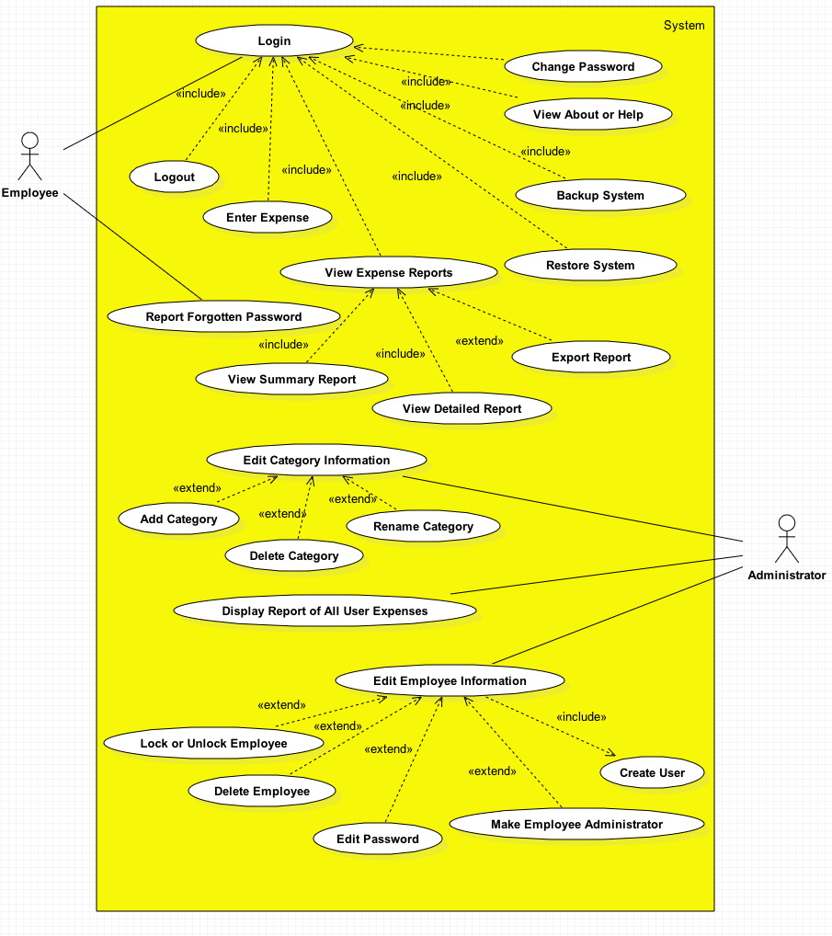

UML Class Diagrams:

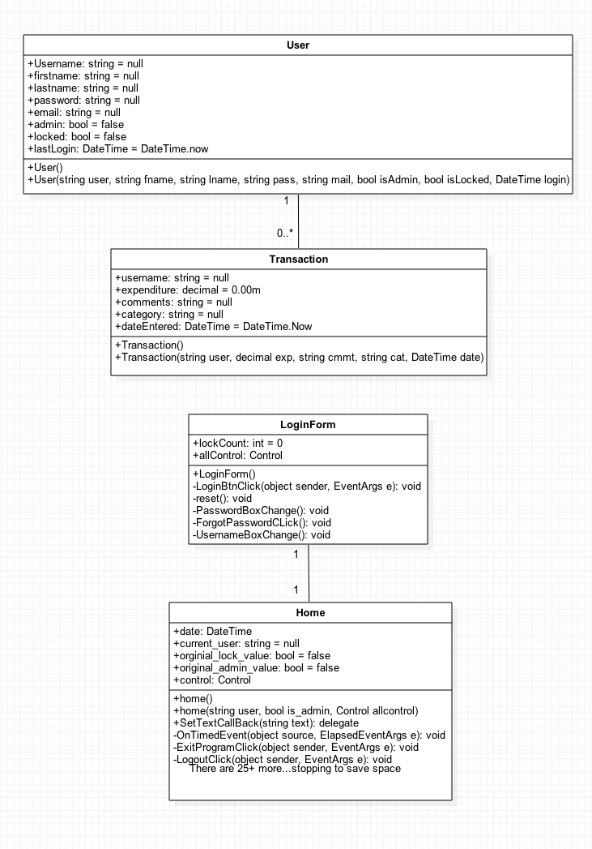

# Interface Requirements

## Employee Interfaces

**Administrator Views:**

1. Login Screen:

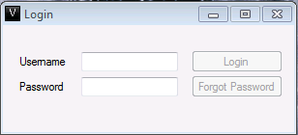

**UI-LOGIN-REQ-1:** 'Username' textbox

**UI-LOGIN-REQ-2:** 'Password' textbox

**UI-LOGIN-REQ-3:** 'Login' button

**UI-LOGIN-REQ-4:** 'Forgot Password' button

**UI-LOGIN-REQ-5:** "Venture Business Management" Icon.

**UI-LOGIN-REQ-6:** "Login" title.

**UI-LOGIN-REQ-7:** Minimize button

**UI-LOGIN-REQ-8:** Maximize button

**UI-LOGIN-REQ-9:** Close button

1. 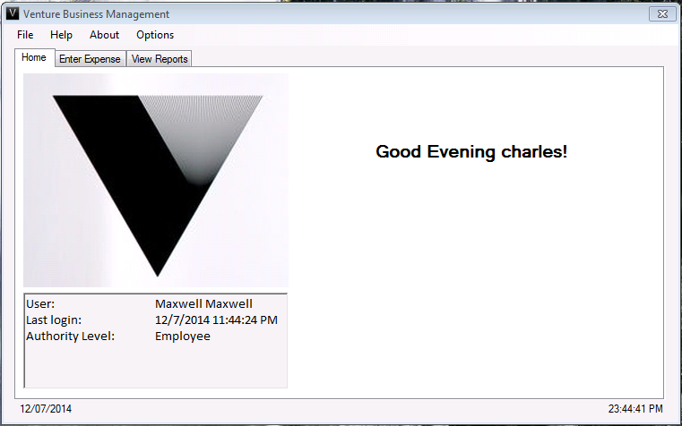Home Tab

**UI-HOME-REQ-1:** Logo.

**UI-HOME-REQ-2:** 'Welcome (name)!' prompt.

**UI-HOME-REQ-3:** Information box with user specific information

**UI-HOME-REQ-4: "**Venture Buisness Management" title.

**UI-HOME-REQ-5: "**Venture Buisness Management" icon.

**UI-HOME-REQ-6:** Tabs with labels: "Home", "Enter Expense", "View Reports"

**UI-HOME-REQ-7:** Close button

**UI-MENU-REQ 1:** Current Time and Date

**UI-MENU-REQ 2:** File menu button

**UI-MENU-REQ 3:** Help menu button

**UI-MENU-REQ 4:** About menu button

**UI-MENU-REQ 5:** Options menu button

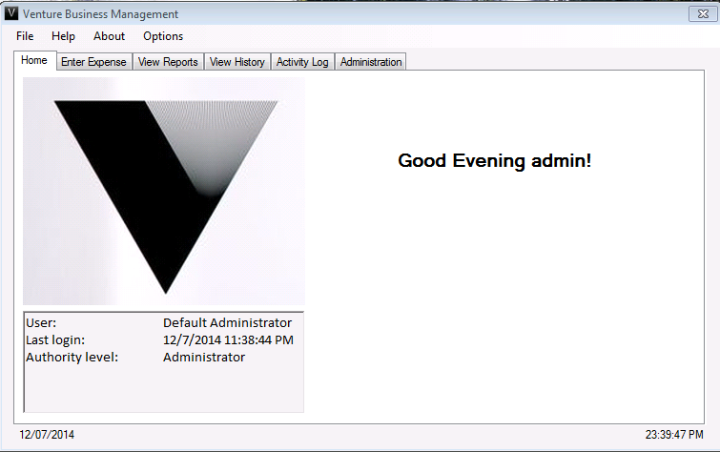

**UI-ADMIN-REQ-1:** Tabs with labels: "Home", "Enter Expense", "View Reports", "View

History", "Activity Log", "Administraton".

1. Expense Entry Tab

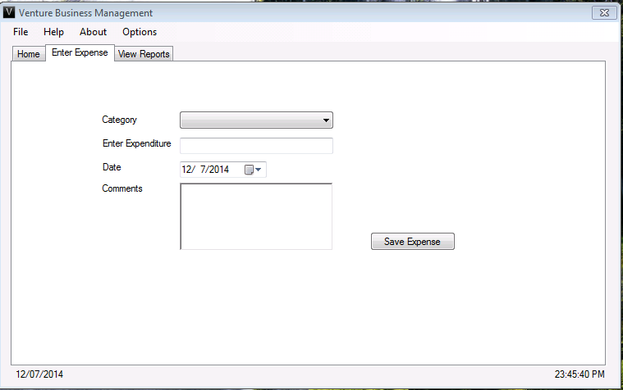

**UI-ENTRY-REQ-1**: Category drop down menu with the following Categories:

|  |  |  |
| --- | --- | --- |
| Mileage | Insurance | Rent (other) |
| Advertising | Insurance (health) | Repairs and maintenance |
| Automobile | Interest (mortgage) | Supplies |
| Commissions & Fees | Interest (other) | Taxes and licenses |
| Contract labor | Legal & professional fees | Travel |
| Depletion | Office Expenses | Travel (meals & entertainment) |
| Employee benefits | Pension & profit sharing plans | Utilities |
|  | Rent (vehicles & equipment) | Wages |

**UI-ENTRY-REQ-2:** Textbox for Expenditure

**UI-ENTRY-REQ-3:** Date selection calendar

**UI-ENTRY-REQ-4:** Text box for entering Comments

**UI-ENTRY-REQ-5:** "Save Expense" button

**UI-ENTRY-REQ-6:** Tabs with labels: "Home", "Enter Expense", "View Reports"

**UI-ENTRY-REQ-7:** "Venture Business Management" Icon.

**UI-ENTRY-REQ-8:** "Venture Business Management" title.

**UI-ENTRY-REQ-9:** Close button

**UI-MENU-REQ-1:** Current Time and Date

**UI-MENU-REQ-2:** File menu button

**UI-MENU-REQ-3:** Help menu button

**UI-MENU-REQ-4:** About menu button

**UI-MENU-REQ-5:** Options menu button

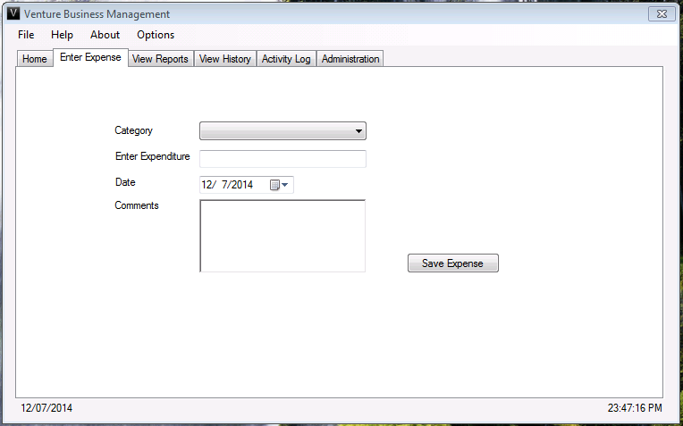

**UI-ADMIN-REQ-1:** Tabs with labels: "Home", "Enter Expense", "View Reports", "View

History", "Activity Log", "Administraton".

1. View Reports Tab:

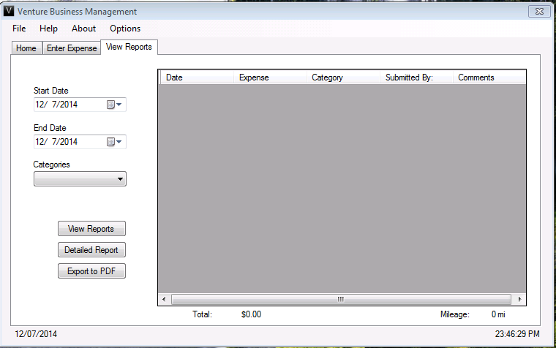

**UI-REPORTS-REQ**-**1:** Start date calendar for date selection

**UI-REPORTS-REQ**-**2:** End date calendar for date selection

**UI-REPORTS-REQ-3:** Categories drop down menu with the following Categories:

|  |  |  |
| --- | --- | --- |
| Mileage | Insurance | Rent (other) |
| Advertising | Insurance (health) | Repairs and maintenance |
| Automobile | Interest (mortgage) | Supplies |
| Commissions & Fees | Interest (other) | Taxes and licenses |
| Contract labor | Legal & professional fees | Travel |
| Depletion | Office Expenses | Travel (meals & entertainment) |
| Employee benefits | Pension & profit sharing plans | Utilities |
|  | Rent (vehicles & equipment) | Wages |

**UI-REPORTS-REQ**-**4: "**View Reports" button

**UI-REPORTS-REQ-5:** "Detailed Report" button

**UI-REPORTS-REQ**-**6:** "Export to PDF" button

**UI-REPORTS-REQ-7:** “Total” displayed below report box

**UI-REPORTS-REQ**-**8:** “Mileage” displayed below report box

**UI-REPORTS-REQ**-**9:** Report box with Columns: "Date", "Expense", "Category", "Submitted By:", "Comments"

**UI-REPORTS-REQ-10:** Report Title

**UI-REPORTS-REQ-11:** Tabs with labels: "Home", "Enter Expense", "View Reports"

**UI-REPORTS-REQ-12:** "Venture Business Management" Icon.

**UI-REPORTS-REQ-13:**"Venture Business Management" title.

**UI-REPORTS-REQ-14:** Close button

**UI-MENU-REQ-1:** Current Time and Date

**UI-MENU-REQ-2:** File menu button

**UI-MENU-REQ-3:** Help menu button

**UI-MENU-REQ-4:** About menu button

**UI-MENU-REQ-5:** Options menu button

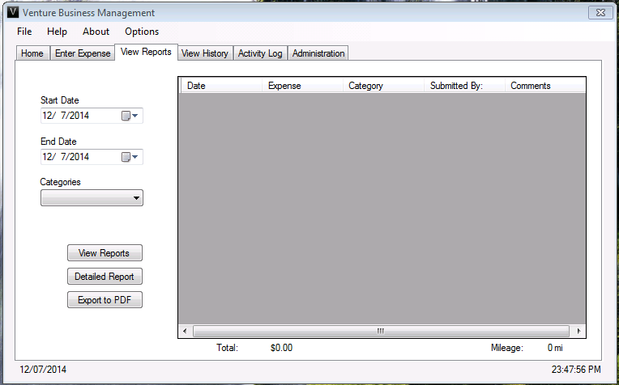

**UI-ADMIN-REQ-1:** Tabs with labels: "Home", "Enter Expense", "View Reports", "View

History", "Activity Log", "Administraton".

1. View History Tab:

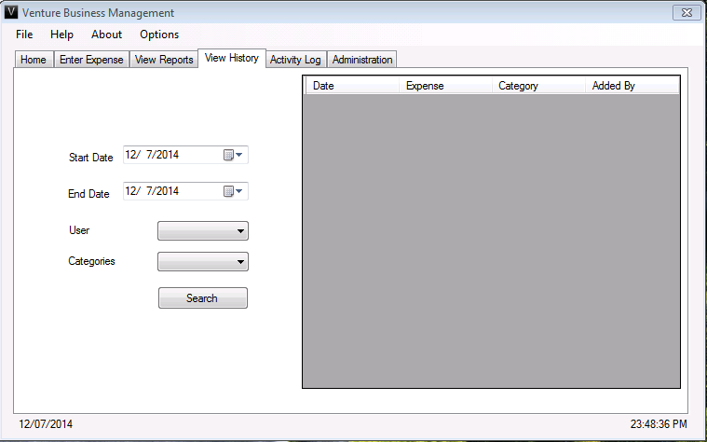

**UI-HISTORY-REQ-1:** Start Date calendar for date selection

**UI-HISTORY-REQ-2:** End Date calendar for date selection

**UI-HISTORY-REQ-3:** User drop down menu with : "All Users" and "admin" as default entries.

**UI-HISTORY-REQ-4:** Category drop down menu with the following categories: "All

Categories" and these:

|  |  |  |
| --- | --- | --- |
| Mileage | Insurance | Rent (other) |
| Advertising | Insurance (health) | Repairs and maintenance |
| Automobile | Interest (mortgage) | Supplies |
| Commissions & Fees | Interest (other) | Taxes and licenses |
| Contract labor | Legal & professional fees | Travel |
| Depletion | Office Expenses | Travel (meals & entertainment) |
| Employee benefits | Pension & profit sharing plans | Utilities |
|  | Rent (vehicles & equipment) | Wages |

**UI-HISTORY-REQ-5:** Report box with Columns: "Date", "Expense", "Category", "Added By:"

**UI-HISTORY-REQ-6:** "Venture Business Management" Icon.

**UI-HISTORY-REQ-7:** "Venture Business Management" title.

**UI-HISTORY-REQ-8:** Close button

**UI-ADMIN-REQ-1:** Tabs with labels: "Home", "Enter Expense", "View Reports", "View

History", "Activity Log", "Administraton".

**UI-MENU-REQ-1:** Current Time and Date

**UI-MENU-REQ-2:** File menu button

**UI-MENU-REQ-3:** Help menu button

**UI-MENU-REQ-4:** About menu button

**UI-MENU-REQ-5:** Options menu button

1. Activity Log Tab:

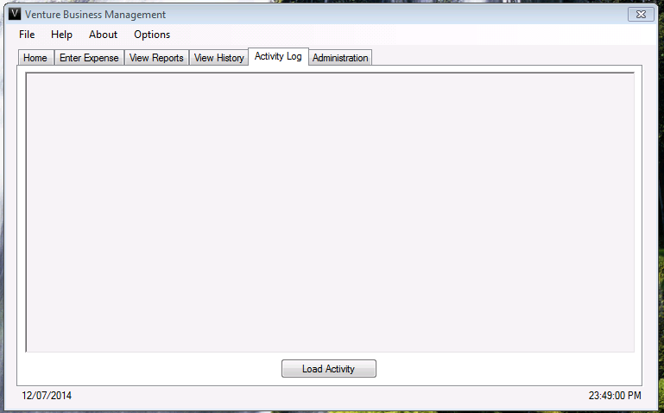

**UI-ACTLOG-REQ 1:** Display box for activity

**UI-ACTLOG-REQ 2:** Load Activity button

**UI-ACTLOG-REQ-3:** "Venture Business Management" Icon.

**UI-ACTLOG-REQ-4:** "Venture Business Management" title.

**UI-ACTLOG-REQ-5:** Close button

**UI-MENU-REQ-1:** Current Time and Date

**UI-MENU-REQ-2:** File menu button

**UI-MENU-REQ-3:** Help menu button

**UI-MENU-REQ-4:** About menu button

**UI-MENU-REQ-5:** Options menu button

**UI-ADMIN-REQ-1:** Tabs with labels: "Home", "Enter Expense", "View Reports", "View

History", "Activity Log", "Administraton".

1. Administrator Options (Add User):

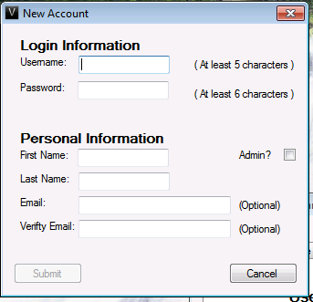

**UI-ADDU-REQ-1:** Username textbox

**UI-ADDU-REQ-2:** Password textbox

**UI-ADDU-REQ-3:** First Name textbox

**UI-ADDU-REQ-4:** Last Name textbox

**UI-ADDU-REQ-5:** Email textbox

**UI-ADDU-REQ-6:** Verify Email textbox

**UI-ADDU-REQ-7:** Admin? checkbox

**UI-ADDU-REQ-8:** “Submit” button

**UI-ADDU-REQ-9:** "Cancel” button

**UI-ADDU-REQ-10:** "Venture Business Management" Icon.

**UI-ADDU-REQ-11:** "New Account" title.

**UI-ADDU-REQ-12:** Close button

1. Administrator Options:

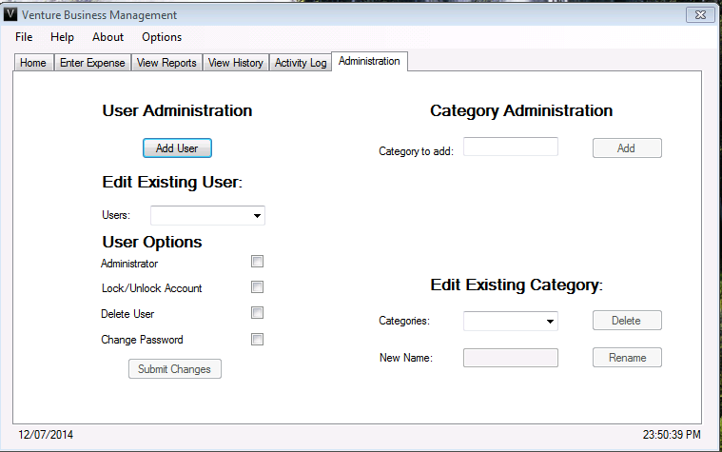

**UI-ADDU-REQ-13:** "User Administration" label

**UI-ADDU-REQ-14:** Add User button

**UI-EDITU-REQ-1:** "Edit Exisiting User" label

**UI-EDITU-REQ-2:** Users drop down menu

**UI-EDITU-REQ-3:** "User Options" label

**UI-EDITU-REQ-4:** Administrator checkbox

**UI-EDITU-REQ-5:** Lock/Unlock Account checkbox

**UI-EDITU-REQ-6:** Delete User checkbox

**UI-EDITU-REQ-7:** Change Password checkbox

**UI-AECAT-REQ-1:** "Category Administration" label

**UI-AECAT-REQ-2:** Category to add textbox

**UI-AECAT-REQ-3:** "Add" button

**UI-AECAT-REQ-4:** "Edit Exisiting Category" label

**UI-AECAT-REQ-5:** Categories drop down menu, NO IRS categories.

**UI-AECAT-REQ-6:** “Delete” button

**UI-AECAT-REQ-7:** New Name textbox

**UI-AECAT-REQ-8:** “Rename” button

**UI-ADDU-REQ-15:** "Venture Business Management" Icon.

**UI-ADDU-REQ-16:** "Venture Business Management" title.

**UI-ADDU-REQ-17:** Close button

**UI-ADDU-REQ-18:** Form separator, split form down middle.

**UI-MENU-REQ-1:** Current Time and Date

**UI-MENU-REQ-2:** File menu button

**UI-MENU-REQ-3:** Help menu button

**UI-MENU-REQ-4:** About menu button

**UI-MENU-REQ-5:** Options menu button

**UI-ADMIN-REQ-1:** Tabs with labels: "Home", "Enter Expense", "View Reports", "View

History", "Activity Log", "Administraton".

1. Help Form:

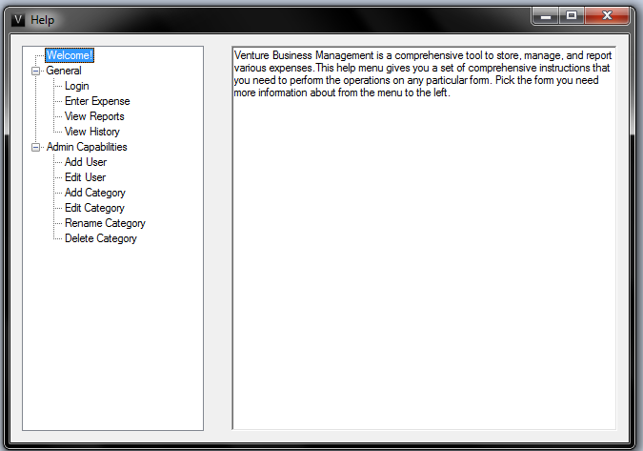

**UI-HELP-REQ-1:** Tree view to the left of the screen with help topics:

Wecome General Admin Capabilities

-Login -Add User

-Enter Expense -Edit User

-View Reports -Add Category

-View History -Rename Category

-Delete Category

**UI-HELP-REQ-2:** Blue highlighting box on selection.

**UI-HELP-REQ-3:** Text in the textbox to the right associated with the selected help topic.

**UI-HELP-REQ-4:** "Venture Business Management" Icon.

**UI-HELP-REQ-5:** "Help" title.

**UI-HELP-REQ-6:** Close button

1. Change Password Form (All Employees)

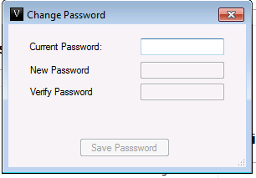

**UI-CHPASS-REQ-1:** Current Password textbox

**UI-CHPASS-REQ-2:** New Password textbox

**UI-CHPASS-REQ-3:** Verify Password textbox

**UI-CHPASS-REQ-4:** Save Password button

**UI-CHPASS-REQ-5:** "Venture Business Management" Icon.

**UI-CHPASS-REQ-6:** "Change Password" title.

**UI-CHPASS-REQ-7:** Close button

1. Change Password Form (Adminstrator)

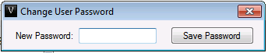

**UI-CHPASS-REQ-8:** New Password textbox

**UI-CHPASS-REQ-9:** Save Password button

**UI-CHPASS-REQ-10:** "Venture Business Management" Icon.

**UI-CHPASS-REQ-11:** "Change User Password" title.

**UI-CHPASS-REQ-12:** Close button

1. Backup Forms

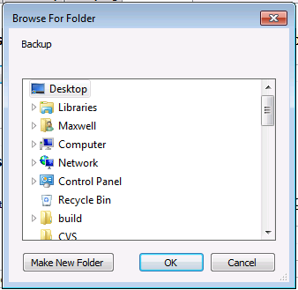

**UI-BACKUP-REQ-1:** Windows file explorer

**UI-BACKUP-REQ-2:** Make New Folder button

**UI-BACKUP-REQ-3:** Ok button

**UI-BACKUP-REQ-4:** Cancel button

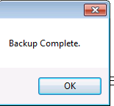

**UI-BACKUP-REQ-5:** Confirmation window: "Backup Complete."

**UI-BACKUP-REQ-6:** "OK" button.

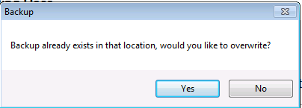

**UI-BACKUP-REQ-7:** Confirmation window: "Backup already exists in that location, would you

like to overwrite?"

**UI-BACKUP-REQ-8:** "Yes" button.

**UI-BACKUP-REQ-9:** "No" button.

**UI-BACKUP-REQ-10:** Close button.

1. Restore Forms

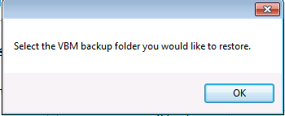

**UI-RESTORE-REQ-1:** Select Window: "Select the VBM Backup folder you would like to

restore."

**UI-RESTORE-REQ-2:** "OK" button.

**UI-RESTORE-REQ-3:** Close button.

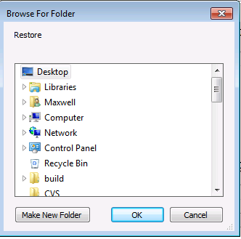

**UI-RESTORE-REQ-4:** Windows file explorer

**UI-RESTORE-REQ-5:** Make New Folder button

**UI-RESTORE-REQ-6:** "OK" button

**UI-RESTORE-REQ-7:** Cancel button

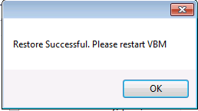

**UI-RESTORE-REQ-8:** Confirmation window: "Restore Successful. Please restart VBM"

**UI-RESTORE-REQ-9:** "OK" button.

**UI-RESTORE-REQ-10:** Close button.

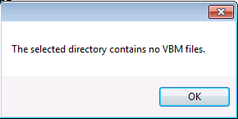

**UI-RESTORE-REQ-11:** Invalid window: "The selected directory contains no VBM files."

**UI-RESTORE-REQ-12:** "OK" button.

1. About Form:

## Mac HD:Users:Apple:Desktop:Screen Shot 2014-12-07 at 11.54.37 PM.png

**UI-ABOUT-REQ 1:** Logo picture to the left.

**UI-ABOUT-REQ 2:** Information to the right about the application.

Company Name

Version Number

Copyright Information

Team name

Description of Application

**UI-ABOUT-REQ-3:** "About Venture Business Management" title.

**UI-ABOUT-REQ-4:** Close button

**UI-ABOUT-REQ-5:** "OK" buton

15. Menu Button Dropdowns:

File Dropdown:

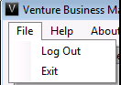

**UI-MENU-REQ-6:** File label

**UI-MENU-REQ-7:** "Logout" button

**UI-MENU-REQ-8:** "Exit" button

Help Dropdown:

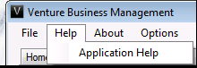

**UI-MENU-REQ-9:** "Application Help" button

About Dropdown:

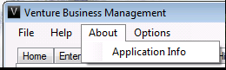

**UI-MENU-REQ-10:** "Application Info" button

Options Dropdown:

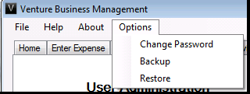

**UI-MENU-REQ-11:** "Change Password" button

**UI-MENU-REQ-12:** "Backup" button

**UI-MENU-REQ-13:** "Restore" button

## Hardware Interfaces

*None*

## Software Interfaces

**S-REQ-17** Venture Business Management must work as described on the following Operating Systems:

Windows 7

Windows 8

Programmer Requirements:

Venture Business Management will not interface with any other software components. No data will be shared with any other software.

Venture Business Management data will be stored locally in the form of XML files. Venture Business Management will directly read and write to the files.

Venture Business Management requires no special communications setup or protocols.

## Performance Requirements

## Safety Requirements

## Security Requirements

The first phase will not include any identity authentication requirements The first phase has no requirements for data encryption or protection.

## Software Quality Attributes

# Other Requirements

Data will be stored in a file using an XML schema to be designed by the Programmers. Programmers will “pair program”, working as a team and strive to cooperate. Programmers will take turns at the keyboard. Programmers may not talk to Testers except to hand off code for testing. All communication between Programmers and Testers will go through the Analyst(s) or bug database.

**S-REQ-18** Venture Business Management will have an option for the user to go back to the “Home” screen at any point.

**S-REQ-19** Venture Business Management asks for confirmation when the Employee identifies his or her intention to Exit.

**S-REQ-20** The application will only provide an initial admin account with the username ‘admin’ and password ‘admin’ both in lowercase, upon initial launch of the software.

**S-REQ-21** Only one instance of Venture Business Management will be running at all times.

**S-REQ-22** A help/about tab will be available on each form for the user to seek guidance in using Venture Business Management

**S-REQ-23** Venture Business Management should have an icon at the top of each form and for the .exe in the taskbar.

**S-REQ-24** The initial screen after login will be unique based off the user type. Admins will have the View Reports form load upon logging in. Regular users will have the expense entry form load upon logging in.

**S-REQ-25** There will be separate XML files for the expenses, employee_admin accounts.

**S-REQ-26** User passwords in the XML files will be hashed/encrypted.

**S-REQ-27** All success messages will be displayed in green.

**S-REQ-28** All error messages will be displayed in red.

**S-REQ-29** Upon the first use of the program, a prompt will be shown to the user advising them to create a new administrator account, and locked the "admin" account.

**S-REQ-30** The application will allow for the Employee to logout at any time.

# Approval

*Before beginning work on Venture Business Management, all parties must sign off on the SRS*

## Phase 1

|  |  |  |  |
| --- | --- | --- | --- |
| **ROLE** | **NAME** | **SIGNATURE** | **DATE** |
| Programmer | *Michelle Jaro* |  |  |
| Programmer | *Karan Singh* |  |  |
| Software Analyst | *Ranier Limpiado* |  |  |
| Software Analyst | *Augustin Garcia* |  |  |
| Tester | *Jeff Henry* |  |  |
| Tester | *Maxwell Partington* |  |  |

## Phase 2

|  |  |  |  |
| --- | --- | --- | --- |
| **ROLE** | **NAME** | **SIGNATURE** | **DATE** |
| Programmer | *Maxwell Partington* |  |  |
| Programmer | *Ranier Limpiado* |  |  |
| Software Analyst | *Jeff Henry* |  |  |
| Software Analyst | *Karan Singh* |  |  |
| Tester | *Michelle Jaro* |  |  |
| Tester | *Augustin Garcia* |  |  |

## Phase 3

|  |  |  |  |
| --- | --- | --- | --- |
| **ROLE** | **NAME** | **SIGNATURE** | **DATE** |
| Programmer | *Jeff Henry* |  |  |
| Programmer | *Augustin Garcia* |  |  |
| Software Analyst | *Michelle Jaro* |  |  |
| Software Analyst | *Maxwell Partington* |  |  |
| Tester | *Ranier Limpiado* |  |  |
| Tester | *Karan Singh* |  |  |

# Appendix A: Glossary

**About: This refers to the form that will hold information about the**

**application.**

**Account: An employee or administrator will have an username and password**

**in the application for entering expenses.**

**Actor: This is either an Employee or an Administrator that will use the**

**application.**

**Activity: Any particular action an Actor takes when using the application.**

**Activity Log: A list of all of the activities made by an Actor.**

**Administrator: An Actor that utilize more specific features of the application. Such**

**as adding employees, adding categories, etc.**

**Analyst: A person who keeps track of the progress of the application, and**

**documents all necessary information about the progress.**

**Backup: This is a function provide by the application that allows Actors to**

**save their information from the application to a secure area.**

**Category: Names of types expenses that will be associated with a monetary**

**cost.**

**Comment: Optional text about an expense and it's cost.**

**C#: A programming language used to write the current application.**

**Date: A calendar day which will be associated with an expense.**

**Data Grid View: A C# form display that will show the Actor their request reports in a**

**grid-like format.**

**Delete: Remove something from the application entirely.**

**Detailed Report: Similar to a report, but with added columns and information to be**

**evaluated by an Actor.**

**Employee: An Actor of the system that can utilize basic features and not make**

**any major edits except for changing their own password.**

**End Date: The final date chosen by a user when requesting a report or history.**

**Expenditure: A monetary value associated with a category in the application.**

**Expense: (See Expenditure)**

**Export to PDF: This will send any generated report to a PDF format for the Actor.**

**Help: A form that will display elaborated information on aspects of the**

**application.**

**Lock/Unlock: These actions will either (lock) keep an Actor from logging in to**

**to the application, or allow them to login in.**

**Login An Actor will type their username and password into the "Login"**

**window and be granted access to the application.**

**Logout An Actor will exit the program by selecting this option from the "File"**

**dropdown menu.**

**PDF An abbreviation of the phrase "Portable Document Format". This**

**format is used to export reports from the application.**

**Programmer: A person who writes the actual code for the application.**

**Report: A requested summary of all expenses made by Actors of the system.**

**Restore: When a backup is created by an Actor, they can bring the information**

**back into the application.**

**Search: An Actor can perform a query of the application to receive information**

**about expenses that have been entered.**

**Start Date: The initial date in a time frame specified by an Actor when requesting a report.**

**SRS: Software Requirements Specifications, a living document maintained**

**by Analysts.**

**Tester: A person that utilizes the SRS' use cases and checks that the product**

**being developed is in line with the SRS.**

**Use Case: A series of steps that illustrates how certain aspects of the application**

**will run.**

**User: (See Actor)**

**Venture Business Management**: The programming assignment to be completed by Team 2.

# Appendix B: Use Case Documentation

**USE CASE 1: Identify Employee**

**1. Use Case Identification**

* 1. **Use Case Name:**

*Identify Employee*

**1.2 Use Case History**

|  |  |  |  |
| --- | --- | --- | --- |
| **Name** | **Date** | **Reason For Changes** | **Use Case Version** |
| Jeff Henry | 10/21/2014 | Initial Creation | 1.0 |
| Jeff Henry | 10/21/2014 | Fixed error on missing exceptions | 1.1 |
| Maxwell Partington | 11/15/2014 | Updated normal flow and exception flows. | 1.2 |
| Maxwell Partington | 12/7/2014 | Finalized Use Case. | 1.3 |

**2. Use Case Definition**

**2.1 Actors**

*Employee*

*Administrator*

**2.2 Description**

*The application opens to a "Login" window, giving an Employee access to the applications features. The Employee will login by entering their valid username and password. After login, the Employee can view their login information such as a last login date and their authority level (Employee/Admin) on the home screen. The current system time and date is displayed. Depending on authority level, Employees and Administrators will have access to certain application features.*

**2.3 Preconditions**

*None*

**2.4 Postconditions**

*The Actor will be logged into the application. If the Actor is an Employee, the "Enter Expense" tab will be shown. If the Actor is an "Adminstrator" the "View Reports" tab will be shown.*

**2.6 Normal Flow**

*1. Actor enters a valid username into the Username textbox.*

*2. Actor enters a valid password into the Password textbox.*

*3. Actor clicks, or hits the enter key to use, the “Login” button. [E1] [E2] [E3] [E4]*

*4. Use case ends.*

*5. Actor can exit use case at any time.*

**2.7 Sub-Flows**

*None*

**2.8 Exception Flows**

*[E1] – The Actor enters a username less than 5 characters. The application prevents the Actor from logging in and displays an error icon to the right of the username textbox and an error message underneath the password textbox that states: "Username is too short." Username textbox is cleared. Password textbox is cleared. Cursor moves back to Username textbox. Normal flow returns to step 1.*

*[E2] – The Actor's entered username does not exist in the system. The system prevents the Actor from logging in and displays an error message underneath the password textbox saying: "User does not exist. Try Again." Username textbox is cleared. Password textbox is cleared. Cursor moves back to Username textbox. Normal flow returns to step 1.*

*[E3] – The Actor entered a password less than 6 characters. The system prevents the Actor from logging in and displays an error icon to the right of the password textbox and an error message underneath the password textbox saying: “Password is too short.” Password textbox is cleared. Cursor is removed from password textbox. Normal flow returns to step 2.*

*[E4] – The Actor's Username and Password do not Match. The system prevents the user from logging in and displays an error message underneath the password textbox that states: “Invalid password. Try Again.” Password textbox is cleared. Cursor is removed from password textbox. Normal flow returns to step 2.*

**USE CASE 2: Expense Entry**

**1. Use Case Identification**

**1.1 Use Case Name:**

*Expense Entry*

**1.2 Use Case History**

|  |  |  |  |
| --- | --- | --- | --- |
| **Name** | **Date** | **Reason For Changes** | **Use Case Version** |
| Jeff Henry | 10/21/2014 | Initial Creation | 1.0 |
| Maxwell Partington | 11/15/2014 | Updated Normal Flow and Exception Flows | 1.1 |
| Maxwell Partington | 12/7/2014 | Finalized Use Case | 1.2 |

**2. Use Case Definition**

**2.1 Actors**

*Employee*

*Administrator*

**2.2 Description**

*The Actor clicks the “Enter Expense” tab in the application and is given the option to enter an expense into the system. The Actor selects a category from the drop down list, enters a valid expense amount, optionally selects a date from the calendar, and optionally types comments about the expense. The Actor clicks the “Save Expense” button or hits the "Enter" key, to enter the expense, and is notified if the expense was successfully saved.*

**2.3 Preconditions**

*Use Case: Identify Employee*

**2.4 Postconditions**

*The Actor's expense that they typed into the "Enter Expense" form, will be saved to the system and the "Expense has been saved" message will display under the comments textbox.*

**2.5 Normal Flow**

*1. Actor clicks on the “Enter Expense” tab.*

*2. Actor selects a category from the drop down list.*

*3. Actor selects the "Expense Amount" textbox.*

*4. Actor types an expense amount.*

*5. Actor selects a date from the calendar.*

*6. Actor enters notes or comments (not required).*

*7. Actor clicks the “Save Expense” button. [E1] [E2] [E3][E4] [E5]*

*8. Use case ends.*

*9. Actor can exit use case at any time.*

**2.6 Sub-Flows**

*None*

**2.7 Exception Flows**

*[E1] – The Actor does not select a category from the drop down list. The application doesn’t allow the expense to be entered when clicking the “Save Expense” button. An error icon is displayed next to the category drop down and an error message will be displayed underneath the "Comments" textbox that states: “Please select a category.” Normal flow returns to step 2.*

*[E2] – The Actor does not enter a valid decimal amount for mileage. The application doesn’t allow the expense to be entered. An error icon is displayed next to the "Enter Expenditure" textbox and an error message will be displayed underneath the "Comments" textbox that states: “Please enter a valid mileage. Ex (1234.5).” Cursor is removed from "Enter Expenditure" textbox. Normal flow returns to step 4.*

*[E3] – The Actor enters a value greater than 6 digits for mileage. The application doesn’t allow the expense to be entered. . An error icon is displayed next to the "Enter Expenditure" textbox and an error message will be displayed underneath the "Comments" textbox that states: “Expense is too large for a mileage.” "Enter Expenditure" textbox is not cleared, cursor is removed from "Enter Expenditure" textbox. Normal flow returns to step 4.*

*[E4] – The Actor does not enter a valid decimal amount for a monetary expense. The application doesn’t allow the expense to be entered when clicking the “Save Expense” button. An error icon is displayed next to the "Enter Expenditure" textbox and an error message will be displayed underneath the "Comments" textbox saying: “Please enter a valid expense. Ex (25).” "Enter Expenditure" textbox isn't cleared, the cursor is removed from "Enter Expenditure" textbox. Normal flow returns to step 4.*

*[E5] – The Actor does not enter any decimal amount for a monetary expense. The application doesn’t allow the expense to be entered when clicking the “Save Expense” button. . An error icon is displayed next to the "Enter Expenditure" textbox and an error message will be displayed underneath the "Comments" textbox saying: “Please enter an expense.” The cursor is removed from "Enter Expenditure" textbox. Normal flow returns to step 4.*

**USE CASE 3: View Reports**

**1. Use Case Identification**

**1.1 Use Case Name:**

*View Reports*

**1.2 Use Case History**

|  |  |  |  |
| --- | --- | --- | --- |
| **Name** | **Date** | **Reason For Changes** | **Use Case Version** |
| Jeff Henry | 10/21/2014 | Initial Creation | 1.0 |
| Maxwell Partington | 11/15/2014 | Update the normal flow and exception flow. | 1.1 |
| Maxwell Partington | 11/15/2014 | Added postconditions. | 1.2 |
| Maxwell Partington | 12/7/2014 | Finalized Use Case | 1.3 |

**2. Use Case Definition**

**2.1 Actors**

*Employee*

*Administrator*

**2.2 Description**

*The Actor clicks the View Reports tab in the application and can perform a query on expense entries that have been entered by the Actor that are stored in the system. The actor will specify a start date and end date from the calendar date selectors. The actor will select a category to choose from and will click the “View Reports” button and a display of all relevant expenses will be updated to the gridview display.*

**2.3 Preconditions**

*Use Case: Identify Employee*

**2.4 Postconditions**

*The application will be shown the reports that the Actor specified via the dates and category selected.*

**2.5 Normal Flow**

*1. Actor clicks on the “View Reports” tab.*

*2. Actor selects a start date from the "Start Date" selection box.*

*3. Actor selects an end date from the "End Date" selection box.*

*4. Actor selects a category from the drop down list.*

*5. Actor clicks the “View Reports” button. [S1] [E1]*

*6. Actor clicks the "Detailed Report" button. [S2] [E1]*

*7. Actor clicks the "Export to PDF" button. [S3] [E2]*

*8. Use case ends.*

*9. Actor can exit the use case at any time.*

**2.6 Sub-Flows**

*[S1] View Reports*

*1. A summary view of the category specified expense reports is displayed in the*

*gridview.*

*[S2] Detailed Reports*

*1. A detailed view of the category speicified expense reports is display in the gridview*

*to the right.*

*[S3] Export to PDF*

*1. A Windows explorer window displays and asks the Actor to specify a location to*

*save their report.*

*2. A PDF is opened by the application to display the report.*

**2.7 Exception Flows**

*[E1] – The Actor does not select a category from the drop down list upon clicking the “View Reports” button. The system does not update the gridview display with reports and displays an error icon next to the Categories dropdown, and an error message underneath the "Export to PDF" button that states: “Please select a category.”. Normal flow returns to step 5.*

*[E2] – The Actor does not generate a report in the gridview by selecting a "Category", then clicking either "View Reports" or "Detailed Reports". An error message box (OK) displays that states: "Please generate a report to export.". The Actor must click "OK". Normal flow returns to step 4.*

**USE CASE 4: View History (Administrator)**

**1. Use Case Identification**

**1.1 Use Case Name:**

*View History (Administrator)*

**1.2 Use Case History**

|  |  |  |  |
| --- | --- | --- | --- |
| **Name** | **Date** | **Reason For Changes** | **Use Case Version** |
| Jeff Henry | 10/21/2014 | Initial Creation | 1.0 |
| Maxwell Partington | 11/15/2015 | Updated the normal flow and exception flow. | 1.1 |
| Maxwell Partington | 12/7/2014 | Finalized Use Case | 1.2 |

**2. Use Case Definition**

**2.1 Actors**

*Administrator*

**2.2 Description**

*The Actor opens the View History tab in the software and can perform a query on Employee expense entry activity. The Actor can select a start and an end date, a user from a drop down list, and a category from a drop down list. A history of all expenses entered by the specified user will be updated to the gridview list.*

**2.3 Preconditions**

*Use Case: Identify Employee*

**2.4 Postconditions**

*The application will display the history of expenses entered associated with the dates, user, and category selected by the Actor.*

**2.5 Normal Flow**

*1. Actor clicks on the “View History” tab.*

*2. Actor selects a start date from the "Start Date" selection box.*

*3. Actor selects an end date from the "End Date" selection box.*

*4. Actor selects a Username from the "User" drop down box.*

*5. Actor selects a Category from the "Categories" drop down box.*

*6. Actor clicks the “Search” button. [E1] [E2]*

*7. Use case ends.*

*8. The Actor can exit the use case at any time.*

**2.6 Sub-Flows**

*None*

**2.7 Exception Flows**

*[E1] – The Actor clicks the "Search" button but does not select a user. An error icon appears beside the "User" drop down menu, and an error message is displayed below the search button that states: "Select a user or category." Normal flow returns to step 4.*

*[E2] – The Actor clicks the "Search" button but does not select a category. An error icon appears beside the "Category" drop down menu, and an error message is displayed below the search button that states: "Select a user or category." Normal flow returns to step 5.*

**USE CASE 5: Employee Administration**

**1. Use Case Identification**

**1.1 Use Case Name:**

*Employee Administration*

**1.2 Use Case History**

|  |  |  |  |
| --- | --- | --- | --- |
| **Name** | **Date** | **Reason For Changes** | **Use Case Version** |
| Jeff Henry | 10/21/2014 | Initial Creation | 1.0 |
| Maxwell Partington | 11/15/2014 | Updated normal flow, sub-flows, and exception flows. | 1.1 |
| Maxwell Partington | 11/30/2014 | Updated normal flows, sub-flows, exception flows. | 1.2 |
| Maxwell Partington | 12/7/2014 | Finalized Use Case | 1.3 |

**2. Use Case Definition**

**2.1 Actors**

*Administrator*

**2.2 Description**

*The Actor clicks the “Administration” tab and is given the option to create an employee, lock an employee, and assign a regular employee as an administrator. The Actor will select an employee from the "Employee" drop down list to make the selected employee an administrator or lock their account. Otherwise the administrator can create a new employee account by selecting the “Create User” button.*

**2.3 Preconditions**

*Use Case: Identify Employee*

**2.4 Postconditions**

*The software will update the Employee selected by the administrator with their desired changes. It will also start the "Create User" use case if specified by the administrator.*

**2.5 Normal Flow**

*1. Actor clicks the “Administration” tab.*

*2. Application shows "Administration" tab window.*

*3. Actor clicks the "Add User" button. [S1]*

*4. Actor selects an Employee from the "User" drop down list. [S2] [S3]*

*5. Use case ends.*

*6. Actor can exit use case at any time.*

**2.6 Sub-Flows**

*[S1]*

*1. Start: "Create User" Use Case.*

*[S2]*

*1. Actor clicks “ Administrator” check box.*

*2. Actor clicks "Lock/Unlock Account” check box.*

*3. Actor clicks “Submit Changes” button. [E1]*

*4. Actor confirms changes via a message box window (OK).*

*[S3]*

*1. Actor clicks "Change Password" check box.*

*2. Actor clicks "Submit Changes" check box.*

*3. The "Change User Password" form is opened.*

*4. Actor enters the new password in the "New Password" textbox*

*5. Actor clicks "Save Password"*

**2.7 Exception Flows**

*[E1] – The Actor selects both "Administrator” and “Lock/Unlock Account”. Upon clicking the “Submit Changes” button, the system will display an error message underneath the "Submit Changes" button that states: “An Administrator account can’t be locked.” Sub-flow returns to Normal flow step 4.*

**USE CASE 6: Category Administration**

**1. Use Case Identification**

**1.1 Use Case Name:**

*Category Administration*

**1.2 Use Case History**

|  |  |  |  |
| --- | --- | --- | --- |
| **Name** | **Date** | **Reason For Changes** | **Use Case Version** |
| Jeff Henry | 10/21/2014 | Initial Creation | 1.0 |
| Maxwell Partington | 12/7/2014 | Finalized Use Case | 1.1 |

**2. Use Case Definition**

**2.1 Actors**

*Administrator*

**2.2 Description**

*The Actor selects the Administration tab and will be able to add, edit, and delete categories. If the Actor wants to delete a category, the Actor will select a category from the drop down list, then select the “Delete” button. If the Actor wants to add a new category, the Actor enter a new name and will click the “Add” button. If the Actor wants to edit a Category, the Actor will select a Category to Edit from the "Categories" dropdown list and enter a new name, and click "Rename".*

**2.3 Preconditions**

*Use Case: Identify Employee*

**2.4 Postconditions**

*The application will successfully update the Categories information, add a new Category, or delete one depending on the Administrators selections.*

**2.5 Normal Flow**

*1. The Actor clicks on the “Administration” tab.*

*2. The "Administration" form is displayed.*

*3. The Actor clicks on the "Category to add:" textbox. [S1]*

*4. The Actor selects the "Categories" drop down list.*

*5. The Actor selects a Category from the category drop down list.*

*6. The Actor clicks the "Delete" button. [S2]*

*7. The Actor selects the “New Name:” textbox. [S3]*

*8. Use case ends.*

*9. The Actor can exit the Use Case at any time.*

**2.6 Sub-Flows**

*[S1]*

*1. The Actor types a new Category name in the "Category to add:" textbox.*

*2. The Actor clicks the "Add" button. [E1]*

*3. The Actor confirms the Category was added via a message box window (OK): "'New Name' has been saved."*

*[S2]*

*1. The Application displays a verification window message box (OK): "Category: '<category name>' has been deleted."*

*[S3]*

*1. The Actor types a new category name into "New Name:" textbox.*

*2. Actor clicks the “Rename” button [E1]*

*3. The Application displays a verification window message box (OK): "Category: '<category name>' has been renamed."*

**2.7 Exception Flows**

*[E1] – The Actor enters a category name that already exists. The system does not create a duplicate category and displays an error message underneath the "Category to add:" textbox that states: “The category ‘<category name>’ already exists.” Cursor is removed from the "Category to add:" textbox. Sub-flow returns to Step 1.*

**USE CASE 7: Logout**

**1. Use Case Identification**

**1.1 Use Case Name:**

*Logout*

**1.2 Use Case History**

|  |  |  |  |
| --- | --- | --- | --- |
| **Name** | **Date** | **Reason For Changes** | **Use Case Version** |
| Jeff Henry | 10/21/2014 | Initial Creation | 1.0 |
| Maxwell Partington | 11/15/2014 | Added Postconditions | 1.1 |
| Maxwell Partington | 12/7/2014 | Finalized Use Case | 1.2 |

**2. Use Case Definition**

**2.1 Actors**

*Employee*

*Administrator*

**2.2 Description**

*The Actor selects the file option on the menu and selects the “Logout” option. The Actor will be logged of their account and the system will return to the "Login" screen.*

**2.3 Preconditions**

*Use Case: Identify Employee*

**2.4 Postconditions**

*The Actor will be logged out of the application.*

**2.5 Normal Flow**

*1. The Actor selects the “File” option in the menu bar.*

*2. The Actor selects the “Logout” option on the "File" drop down menu.*

*3. Use case ends.*

*4. The Actor can exit the Use Case at anytime.*

**2.6 Sub-Flows**

*None*

**2.7 Exception Flows**

*None*

**USE CASE 8: Create User**

**1. Use Case Identification**

**1.1 Use Case Name:**

*Create User*

**1.2 Use Case History**

|  |  |  |  |
| --- | --- | --- | --- |
| **Name** | **Date** | **Reason For Changes** | **Use Case Version** |
| Jeff Henry | 10/22/2014 | Initial Creation | 1.0 |
| Maxwell Partington | 11/15/2014 | Updated exception flows, clarified actors. | 1.1 |
| Maxwell Partington | 12/7/2014 | Finalized Use Case | 1.2 |

**2. Use Case Definition**

**2.1 Actors**

*Administrator*

**2.2 Description**

*The Actor selects the administration tab and will be able to create a new user when the “Add User” button is clicked.*

**2.3 Preconditions**

*Use Case: Employee Adminstration*

*1. An Administrator has logged in.*

*2. An Administrator has clicked the "Add User" button on the adminstration tab.*

**2.4 Postconditions**

*The application will successfully create a user and save them into the XML.*

**2.5 Normal Flow**

*1. The "New Account" form is displayed.*

*2. The Actor types a new username for the user in the "Username:" textbox. [E1]*

*3. The Actor types a new password for the employee in the "Password:" textbox. [E2]*

*4. The Actor types a new first name for the employee in the "First Name:" textbox.*

*5. The Actor types a new last name for the employee in the "Last Name:" textbox.*

*6. The Actor types a new email for the employee in the "Email:" textbox.*

*7. The Actor types a new verified email for the employee in the "Verify Email:" textbox.*

*8. The Actor clicks the “Submit” button. [E3] [E4] [E5] [E6] [E7] [E8] [E9] [E10]*

*9. Use Case ends.*

*10. The Actor can exit the Use Case at any time.*

**2.6 Sub-Flows**

*None*

**2.7 Exception Flows**

*[E1] - The Actor's entered username is less than 5 characters. The system will display an error icon next to the right of the username textbox until the Actor enters a 5 character username.*

*[E2] – The Actor's entered password is less than 6 characters. The system will display an error icon next to right of the password textbox until the Actor enters a 6 character password.*

*[E3] – The Actor's entered username is less than 5 characters. The system will display an error message underneath the password textbox that states: “Please enter a (minmum 5 character) username using any of the following characters: [a-z] [A-Z] [0-9][ _ ]. ” Username textbox is not cleared. Cursor is removed from Username textbox. Normal flow returns to step 2.*

*[E4] – The Actor's entered password is less than 6 characters. The system will display an error message underneath the password textbox that states: "Please enter a password with 6 characters." Password textbox is not cleared. Cursor is removed from the password textbox. Normal flow returns to step 3.*

*[E5] – The Actor does not enter a first name. The system will display an error message underneath the verify email textbox that states: “Please enter a valid first name. [a-z][A-z][- ']”. Cursor is removed from the first name textbox. Normal flow returns to step 4.*

*[E6] – The Actor does not enter a last name. The system will display an error message underneath the verify email textbox that states: “Please enter a valid last name. [a-z][A-z][- ']”.Cursor is removed from the last name textbox. Normal flow returns to step 5.*

*[E7] – The Actor typed an invalid email format. The system will display an error message underneath the verify email textbox that states: “Please enter a valid email address (Ex. johndoe@aol.com).” Email textbox isn't cleared. Cursor is removed from the email textbox. Normal flow returns to step 6.*

*[E8] – The Actor does not enter a verification email. The system displays an error message underneath the "Verify Email:" textbox that states: “Emails do not match. Please re-enter them.” Cursor is removed from the verify email textbox. Normal flow returns to step 7.*

*[E9] – The Actor enters an email that does not match the first email. The system displays an error message underneath the "Verify Email:" textbox that states: “Emails do not match. Please re-enter them.” Cursor is removed from the verify email textbox. Normal flow returns to step 7.*

*[E10] – The Actor enters a Username that already exists in the system. A message box window is displayed that states: "Username is taken. Please try another." Normal flow returns to step 2.*

**USE CASE 9: About Menu**

**1. Use Case Identification**

**1.1 Use Case Name:**

*About Menu*

**1.2 Use Case History**

|  |  |  |  |
| --- | --- | --- | --- |
| **Name** | **Date** | **Reason For Changes** | **Use Case Version** |
| Karan Singh | 10/30/2014 | Initial Creation | 1.0 |
| Maxwell Partington | 11/15/2014 | Added Postconditions | 1.1 |
| Maxwell Partington | 12/7/2014 | Finalized Use Case | 1.2 |

**2. Use Case Definition**

**2.1 Actors**

*Administrator*

*Employee*

**2.2 Description**

*The Actor selects the "About" menu dropdown, and clicks "Application Info". The Actor will be able to see information about Venture Business Management.*

**2.3 Preconditions**

*Use Case: Identify Employee*

**2.4 Postconditions**

*The application will display the "About" window for the Actor to use.*

**2.5 Normal Flow**

*1. The Actor clicks the “About” button on the 'Menu' bar.*

*2. The Actor clicks the “Application Info” button on the "About" dropdown menu.*

*3. The application displays the "About Venture Business Management" form that displays information about the application.*

*4. Use case ends.*

*5. The Actor can exit the Use Case at any time.*

**2.6 Sub-Flows**

*None*

**2.7 Exception Flows**

*None*

**USE CASE 10: Help Menu**

**1. Use Case Identification**

**1.1 Use Case Name:**

*Help Menu*

**1.2 Use Case History**

|  |  |  |  |
| --- | --- | --- | --- |
| **Name** | **Date** | **Reason For Changes** | **Use Case Version** |
| Karan Singh | 10/30/2014 | Initial Creation | 1.0 |
| Maxwell Partinton | 11/15/2014 | Updated normal flow | 1.1 |
| Maxwell Partington | 12/7/2014 | Finalized Use Case | 1.2 |

**2. Use Case Definition**

**2.1 Actors**

*Administrator*

*Employee*

**2.2 Description**

*The Actor selects the "Help" menu item dropdown and clicks the "Application Help" button. The Actor will be able to search multiple reference options to get information about Venture Business Management.*

**2.3 Preconditions**

*Use Case: Identify Employee*

**2.4 Postconditions**

*The application will display the "Help" window for the Actor to use.*

**2.5 Normal Flow**

*1. The Actor clicks the “Help” menu item button.*

*2. The Actor clicks the "Application Help" button on the "Help" dropdown menuy.*

*3. The application displays the 'Help' window to the left of the main Application*

*window.*

*4. The Actor selects any of the items in the 'Help' tree window.*

*5. The right side of the screen will display pertinent text for the Actor.*

*6. Use case ends.*

*7. The Actor can exit the Use Case at any time.*

**2.6 Sub-Flows**

*None*

**2.7 Exception Flows**

*None*

**USE CASE 11: Exporting Reports**

**1. Use Case Identification**

**1.1 Use Case Name:**

*Exporting Reports*

**1.2 Use Case History**

|  |  |  |  |
| --- | --- | --- | --- |
| **Name** | **Date** | **Reason For Changes** | **Use Case Version** |
| Karan Singh | 10/30/2014 | Initial Creation | 1.0 |
| Maxwell Partington | 11/15/2014 | Use Case Deprecated | 1.1 |
| Maxwell Partington | 11/30/2014 | Restored Use Case. Changed normal flows, exception flow | 1.2 |
| Maxwell Partington | 12/7/2014 | Finalized Use Case | 1.3 |

**2. Use Case Definition**

**2.1 Actors**

*Administrator*

*Employee*

**2.2 Description**

*The Actor selects the “View Reports” tab to generate reports of data entry. Once the reports are generated, the Actor should be allowed to export said report into a PDF formatted document.*

**2.3 Preconditions**

*Use Case: Identify Employee*

**2.4 Postconditions**

*The application will successfully display a report based on the specified dates and category designated by the Actor in a PDF document.*

**2.5 Normal Flow**

*1. The Actor clicks on the “View Reports” tab.*

*2. The Actor selects a category from the drop down list.*

*3. The Actor clicks "View Reports" or "Detailed Report" to generate a report to export. [E1]*

*4. The Actor clicks on “Export to PDF” button [E1] [E2]*

*5. A Windows explorer window is diplayed.*

*6. The Actor will type in the name they desire to save the PDF as.*

*7. The Actor clicks "Save".*

*8. Use case ends.*

*9. Employee can exit the Use Case at any time.*

**2.6 Sub-Flows**

*None*

**2.7 Exception Flows**

*[E1] – The Actor does not select a category from the drop down list. Upon clicking the “View Reports” button or "Detailed Report" button, the system does not update the gridview display with reports and displays an error ircon next to the Categories dropdown and an error message underneath the "Export to PDF" button that states: “Please select a category.” Normal flow returns to step 2.*

*[E2] – The Actor selects a category that does not have any expense entries associated with it. An message box (OK) displays that states: "Please generate a report." The Actor must click "OK". Normal flow returns to step 2.*

**USE CASE 12: Archive (Deprecated)**

**1. Use Case Identification**

**1.1 Use Case Name:**

*Archive*

**1.2 Use Case History**

|  |  |  |  |
| --- | --- | --- | --- |
| **Name** | **Date** | **Reason For Changes** | **Use Case Version** |
| Maxwell Partington | 11/15/14 | Initial Creation | 1.0 |
| Maxwell Partington | 11/30/14 | Functionality not implemented, handled by system. | 1.0 |

**2. Use Case Definition**

**2.1 Actors**

*Administrator*

**2.2 Description**

*The Actor selects the 'File' button in the menu bar and selects the "Archive" button. The Application will open the "Archive" window and the user will select the range of dates to archive and click "Save to Archive" to archive the data.*

**2.3 Preconditions**

*Use Case: User Identified*

**2.4 Postconditions**

*The application will successfully archive the data the Actor specifies to be archived.*

**2.5 Normal Flow**

*1. The Actor clicks on the “File” menu item.*

*2. The Actor clicks the "Archive" button.*

*3. The "Archive" window is displayed.*

*4. Actor selects an start date from the calendar.*

*5. Actor selects a end date rom the calendar.*

*6. Actor clicks the “Save to Archive” button.*

*7. Use case ends.*

*8. Employee can exit the Use Case at any time.*

**2.6 Sub-Flows**

*None*

**2.7 Exception Flows**

*None*

**USE CASE 13: Backup**

**1. Use Case Identification**

**1.1 Use Case Name:**

*Backup*

**1.2 Use Case History**

|  |  |  |  |
| --- | --- | --- | --- |
| **Name** | **Date** | **Reason For Changes** | **Use Case Version** |
| Maxwell Partington | 11/15/14 | Initial Creation | 1.0 |
| Maxwell Partington | 11/30/14 | Moved "Restore" functionality to its own Use Case. Updated Normal flow and sub-flows. | 1.1 |
| Maxwell Partington | 12/7/2014 | Finalized Use Case | 1.2 |

**2. Use Case Definition**

**2.1 Actors**

*Employee*

**2.2 Description**

*The Actor selects menu item "Options" and then the “Backup" button which will open the backup dialouge for the user to Backup their data.*

**2.3 Preconditions**

*Use Case: Identify Employee*

**2.4 Postconditions**

*The application will successfully backup the data to the location the Actor specifies.*

**2.5 Normal Flow**

*1. The Actor clicks on the "Option” menu item.*

*2. The Actor clicks the "Backup " button.*

*3. The Actor selects the backup location in Windows explorer window.*

*4. [S1] or [S2]*

*5. Use case ends.*

*6. Employee can exit the Use Case at any time.*

**2.6 Sub-Flows**

*[S1]*

*1. The first time the system is backed up.*

*2. The Actor clicks the "OK" button to select their location.*

*3. The Application backs up the information to the desired location.*

*4. The Actor confirms the backup via a message box (OK): "Backup Complete".*

*[S2]*

*1. There is an existing backup in the system.*

*2. The Application notifies the Actor that a backup already exists in the location with a pop-up notification that states: "Backup already exists in that location, would you like to overwrite?"*

*3. If The Actor confirms the backup by clicking the "Yes" button, go to step 3.*

*Else [S2] ends.*

*4. The Application backs up the information to the desired location.*

*5. The Actor confirms the backup via a message box (OK): "Backup Complete".*

**2.7 Exception Flows**

*None*

**USE CASE 13: Restore**

**1. Use Case Identification**

**1.1 Use Case Name:**

*Restore*

**1.2 Use Case History**

|  |  |  |  |
| --- | --- | --- | --- |
| **Name** | **Date** | **Reason For Changes** | **Use Case Version** |
| Maxwell Partington | 11/30/14 | Initial Creation | 1.0 |
| Maxwell Partington | 12/7/2014 | Finalized Use Case | 1.2 |

**2. Use Case Definition**

**2.1 Actors**

*Employee*

**2.2 Description**

*The Actor selects "Options" menu item and then the “Restore" button which will open the restore dialouge for the user to Restore their data.*

**2.3 Preconditions**

*Use Case: Identify Employee*

**2.4 Postconditions**

*The application will successfully restore the data from the location the Actor specifies.*

**2.5 Normal Flow**

*1. The Actor clicks on the "Options” menu item.*

*2. The Actor clicks the "Restore" button.*

*3. The Actor clicks OK on the window that states: "Select the VBM backup folder you would like to restore."*

*4. A Windows file explorer is opened.*

*5. The Actor selects a file location of an appropriate VBM backup file.*

*6. The Actor clicks "OK" to restore the backup file. [E1]*

*7. A Message box is displayed that states: "Restore Successful. Please Restart VBM"*

*8. Use Case ends.*

*9. Employee can exit the Use Case at any time.*

**2.6 Sub-Flows**

*None*

**2.7 Exception Flows**

*[E1] -The application displays a message box that states: "The selected directory containts no VBM files." The Actor clicks the "OK" button, the Application returns to main form.*

**USE CASE 14: Application Settings (Deprecated)**

**1. Use Case Identification**

**1.1 Use Case Name:**

*Application Settings*

**1.2 Use Case History**

|  |  |  |  |
| --- | --- | --- | --- |
| **Name** | **Date** | **Reason For Changes** | **Use Case Version** |
| Maxwell Partington | 11/15/14 | Initial Creation | 1.0 |
| Maxwell Partington | 11/30/14 | Functionality not implemented | 1.1 |

**2. Use Case Definition**

**2.1 Actors**

*Administrator*

**2.2 Description**

*The Actor selects Option menu item and then the “Settings” button which will open application settings window for the administrator to modify the look and feel of their application.*

**2.3 Preconditions**

*Use Case: User Identified*

**2.4 Postconditions**

*The applications colors, icon, and name will change to the specified information given by the Actor.*

**2.5 Normal Flow**

*1. The Actor clicks on the "Option” menu item.*

*2. The "Application Settings" window is displayed.*

*3. The Actor enters the new Company name.*

*4. The Actor clicks the "Window Border Color:" "Select Color" button. [S1]*

*4. The Actor clicks the "Window Background Color:" "Select Color" button. [S2]*

*5. The Actor clicks the "Change Logo" button. [S3]*

*6. The Actor clicks the "Update Settings" button. [E1]*

*7. Use case ends.*

*8. Employee can exit the Use Case at any time.*

**2.6 Sub-Flows**

*[S1]*

*1. The application displays a color picker window for the Actor to choose a*

*new color.*

*2. The Actor selects a color of their choosing.*

*3. The Actor clicks "Choose".*

*4. The Applcation closes the color picker window.*

*8. Sub-flow ends.*

*9. The Actor can exit the sub-flow at any time.*

*[S2]*

*1. The application displays a color picker window for the Actor to choose a*

*new color.*

*2. The Actor selects a color of their choosing.*

*3. The Actor clicks "Choose".*

*4. The Applcation closes the color picker window.*

*8. Sub-flow ends.*

*9. The Actor can exit the sub-flow at any time.*

*[S3]*

*1. The application opens a Windows explorer window for the Actor to search for the new logo.*

*2. The Actor searches for and selects their new logo.*

*3. The Actor clicks "Choose".*

*4. The application closes the Windows explorer window.*

*5. Sub-flow ends.*

*6. The actor can exit the sub-flow at any time.*

**2.7 Exception Flows**

*[E1] – The Actor did not make any changes to their application. A message box window is displayed with a message that states: "Confirm no changes to be made to application? (YES/NO). Yes closes the "Application Settings window." No, returns the normal flow to step 2.*

**USE CASE 15: Change Password**

**1. Use Case Identification**

**1.1 Use Case Name:**

*Change Password*

**1.2 Use Case History**

|  |  |  |  |
| --- | --- | --- | --- |
| **Name** | **Date** | **Reason For Changes** | **Use Case Version** |
| Maxwell Partington | 11/15/14 | Initial Creation | 1.0 |
| Maxwell Partington | 12/7/2014 | Finalized Use Case | 1.2 |

**2. Use Case Definition**

**2.1 Actors**

*Administrator*

*Employees*

**2.2 Description**

*The Actor selects "Options" tab, then the "Change Password" button and then is taken a window that will ask them to enter their current password, then their desired new password twice.*

**2.3 Preconditions**

*None*

**2.4 Postconditions**

*The Actors password will be successfully changed. The application will return to the main form.*

**2.5 Normal Flow**

*1. The Actor clicks on the "Options” menu item.*

*2. The Actor clicks the "Change Password" button.*

*3. The Actor enters the Password associated with their account in the "Current*

*Password:" textbox.*

*4. The Actor enters their new password into the "New Password:" textbox.*

*5. The Actor re-enteres their new password into the "Verify Password:" textbox.*

*6. The Actor clicks the "Save Password" button. [E1][E2][E3]*

*7. A message box is displayed (OK) "Your password has been updated.".*

*8. Use case ends.*

*9. Employee can exit the Use Case at any time.*

**2.6 Sub-Flows**

**2.7 Exception Flows**

*[E1] – The Actor entered an invalid password that isn't associated with their account. An error icon is displayed next to the current password textbox, and an message displays underneath the "Verify Password:" textbox that states: "Incorrect Current Password. Please re-enter your current password." The "Current Password" textbox is cleared, cursor stays in "Current Password" textbox. Normal flow returns to step 3.*

*[E2] – The Actor entered mismatching new passwords. An error icon is displayed next to the verify password textbox and an error message is displayed underneath the "Verify Password" textbox that states: "New passwords did not match." "New Password:" and "Verify Password" fields are cleared, cursor returns to new password textbox. Normal flow returns to step 4.*

*[E2] – The Actor entered a password less than 6 characters. An error icon is displayed next to the new password textbox and an error message is displayed underneath the verify password textbox that states: "New Password must be at least 6 characters long." New Password and Verify Password textboxes are not cleared, cursor is removed from textboxes. Normal flow returns to step 4.*

**USE CASE 16: Forgot Password**

**1. Use Case Identification**

**1.1 Use Case Name:**

*Forgot Password*

**1.2 Use Case History**

|  |  |  |  |
| --- | --- | --- | --- |
| **Name** | **Date** | **Reason For Changes** | **Use Case Version** |
| Maxwell Partington | 11/15/14 | Initial Creation | 1.0 |
| Maxwell Partington | 11/30/14 | Removed some normal flow steps. | 1.1 |
| Maxwell Partington | 12/7/2014 | Finalized Use Case | 1.2 |

**2. Use Case Definition**

**2.1 Actors**

*Administrator*

*Employees*

**2.2 Description**

*The Actor selects the "Forgot Password" button and then is shown a message box (OK) that states that a notification has been sent to the Administrators to reset the Actors password.*

**2.3 Preconditions**

*None*

**2.4 Postconditions**

*The application will successfully send a notification to the Administrators with the Actors username notifying them to reset the users password.*

**2.5 Normal Flow**

*1. The Actor enters their username into the username textbox on the login window.*

*2. The Actor clicks the "Forgot Password" button.*

*2. A message box is displayed (OK) "An adminstrator has been notified that you forgot your password."*

*3. Use case ends.*

*4. Employee can exit the Use Case at any time.*

**2.6 Sub-Flows**

*None*

**2.7 Exception Flows**

*None*

**USE CASE 17: Activity Log (Administrator)**

**1. Use Case Identification**

**1.1 Use Case Name:**

*Activity Log (Administrator)*

**1.2 Use Case History**

|  |  |  |  |
| --- | --- | --- | --- |
| **Name** | **Date** | **Reason For Changes** | **Use Case Version** |
| Maxwell Partington | 11/20/2014 | Initial Creation | 1.0 |
| Maxwell Partington | 12/7/2014 | Finalized Use Case | 1.2 |

**2. Use Case Definition**

**2.1 Actors**

*Administrator*

**2.2 Description**

*The Actor opens the Activity Log tab in the software and can view the details of user activity in the software.*

**2.3 Preconditions**

*Use case: Identify Employee*

**2.4 Postconditions**

*The application will display the Activity History of all activity conducted by all Actors of the software.*

**2.5 Normal Flow**

*1. Actor clicks on the “Activity History” tab.*

*2. Actor clicks the “Load Activity” button. [S1]*

*3. A view of all activity is shown in the sotfware.*

*4. Use case ends.*

*5. The Actor can exit the use case at any time.*

**2.6 Sub-Flows**

*None*

**2.7 Exception Flows**

*None*

Pick name from list (Login) Description: Use case 1

|  |  |  |
| --- | --- | --- |
| Name: | Date: | Reason for Changes: |
| Ranier Limpiado | 9/20/2014 | Initial Creation |
| Ranier Limipado | 9/28/2014 |  |
| Jeff Henry | 10/21/2014 | Use Case Deprecated. |

Description: User picks their name from the list to begin entering or viewing data.

Normal Flow:

1. The user picks their name from the user list. It may be an admin or normal user.

2. After choosing a name, the user clicks select.

3. New information shows up on the home and depending on who the user is, the user’s name is shown and the current date and time. Buttons, “Enter Report”, “View Report” will show up on the home form and, the button “View History” button shows up if the user is an Admin.

Trigger: User starts application

Actors: The user and system

Preconditions:

1. Venture Business Management application opens

Postconditions:

1. The user is logged in.

Goals:

1. The user is able to pick their name from the list and login and begin to enter or view data.

Failed Conclusions:

1. Application not opening

2. If the user does not click the “Select” button then the user will not be logged in.

Enter Report Button Description: Use case 2

|  |  |  |
| --- | --- | --- |
| Name: | Date: | Reason for Changes: |
| Ranier Limpiado | 9/20/2014 | Initial Creation |
| Ranier Limipado | 9/28/2014 |  |
| Jeff Henry | 10/21/2014 | Use Case Deprecated. |

Description: The user selects to enter data to the correct category for the designated time frame and the system adds it.

Trigger: User clicks “Enter Report” button.

Actors: The user and system

Preconditions:

1. The user is logged in.
2. The user clicks “Enter Report” button.

Postconditions:

1. The Expense_Data_Entry form is opened.
2. The last login date of the user, the username, and the current date is shown.

Normal flow:

1. The user clicks “Enter Report” button.
2. Expense_Data_Entry form is opened.

Goals:

1. The user is able to begin entering data for the expenditure.

Includes:

1. Use case 1

Failed Conclusions:

1. If the user does not click the “Enter Report” button then the Expense_Data_Entry form won’t be opened.

View Report Button Description: Use case 3

|  |  |  |
| --- | --- | --- |
| Name: | Date: | Reason for Changes: |
| Ranier Limpiado | 9/20/2014 | Initial Creation |
| Ranier Limipado | 9/28/2014 |  |
| Jeff Henry | 10/21/2014 | Use Case Deprecated. |

The system provides a means to view all expenses for a designated time frame. The end-user can request a report of one category or all categories. The end-user designates a time frame for viewing history. The system shows the correct data.

Description: The user selects to view a report by clicking the “View Report” button and the Expense_Reports form opens.

Trigger: Clicking the “View Report” button.

Actors: The user and system

Preconditions:

1. The user is logged in.
2. The user clicks the “View Report” button.

Postconditions:

1. The Expense_Reports form is opened.
2. The user’s name, last login, and current date are shown.

Normal Flow:

1. The user clicks “Enter Report” button.
2. Expense_Reports form is opened

Goals:

1. The user is able to begin entering data for the report they want to view.

Includes:

1. Use case 1

Failed conclusions:

1. If the user does not click the “View Report” button then the Expense_Reports form will not open.

Admin View History button: Use case 4

|  |  |  |
| --- | --- | --- |
| Name: | Date: | Reason for Changes: |
| Ranier Limpiado | 9/20/2014 | Initial Creation |
| Ranier Limipado | 9/28/2014 |  |
| Jeff Henry | 10/21/2014 | Use Case Deprecated. |

Description: User is an admin and wants to view History of reports.

Trigger: User picking to view report

Actors: The user (admin) and system

Preconditions:

1. The user logs in as an admin.
2. The user clicks the “View History” button.

Postconditions:

1. The History form is opened.

Normal flow:

1. The user logs in as an Admin user.
2. The user clicks the “View History” button.
3. The History form opens.

Goals:

1. The admin is able to enter data to begin viewing the history of other users.

Includes:

1. Use case 1

Failed Conclusions:

1. If the user does not click the “View History” button then the History form will not open.

Insert Data: Use case 5

|  |  |  |
| --- | --- | --- |
| Name: | Date: | Reason for Changes: |
| Ranier Limpiado | 9/20/2014 | Initial Creation |
| Ranier Limipado | 9/28/2014 |  |
| Jeff Henry | 10/21/2014 | Use Case Deprecated. |

Description: The user enters the data for the amount and category for the certain date of the expenditure into the system.

Actors: User and System

Trigger: The user clicks the “Enter Report” button.

Normal Flow:

1. The user logs in.
2. The user picks the category to add to.
3. The user enters the amount for the expenditure.
4. The user chooses the date for the expenditure.
5. The user clicks the “Insert” button.
6. The system inserts the data into the xml.

Preconditions:

1. The user is logged in.
2. The user clicked the “Enter Report” button.

Postconditions:

1. The correct amount is inserted to the system in the correct category with the correct date.

Includes:

1. Use case 1
2. Use case 2

Goals:

1. The correct data is added to the system into the correct user’s data.

Failed Conclusions:

1. If the user picks mileage, it should not stop at 2 decimals.
2. If the user does not enter an amount the system should display, “Error: you forgot to enter an expense.”
3. If the user does not pick a category the system should display, “Error: you forgot to enter a category”.

Generate Reports description: Use case 6

|  |  |  |
| --- | --- | --- |
| Name: | Date: | Reason for Changes: |
| Ranier Limpiado | 9/20/2014 | Initial Creation |
| Ranier Limipado | 9/28/2014 |  |
| Jeff Henry | 10/21/2014 | Use Case Deprecated. |

Description: The user selects to view a report and has to pick the start and end date and the category to view the report.

Actors: User and System

Trigger: The user clicks the “View Report” button.

Normal flow:

1. The user logs in.
2. The user clicks the “View Report” Button and the Expense_Reports form pops up.
3. The user picks the start date and end date.
4. The user picks the category they want to view.
5. The user clicks the “View Reports” button.
6. The report is shown on the screen by the system.

Preconditions:

1. The user is logged in.
2. The user clicked the “View Report” button.

Postconditions:

1. The system shows the correct report on the screen.
2. It can be all the categories or one category.

Includes:

1. Use case 1
2. Use case 3

Goals:

1. The user is shown the data they asked for.

Failed Conclusions:

1. If the user does not pick a category the system should display, “Error: You forgot to pick a category.”
2. If the user does not click the “Search” button, then the system will not generate a report.

Show History: Use case 7

|  |  |  |
| --- | --- | --- |
| Name: | Date: | Reason for Changes: |
| Ranier Limpiado | 9/20/2014 | Initial Creation |
| Ranier Limipado | 9/28/2014 |  |
| Jeff Henry | 10/21/2014 | Use Case Deprecated. |

Description: The user is an admin and wants to view the history of a customer.

Actors: User and System

Trigger:

1. The user clicks the “View History” button.

Preconditions:

1. The user logs in as an “Admin” user.
2. The user clicks the “View History” button.

Postconditions:

1. The system shows the correct report on the screen.

Normal flow:

1. The logs in as an “Admin” user.
2. The user clicks the “View History” button and the “History” form pops up.
3. The user picks a customer to view.
4. The user picks the start date.
5. The user picks the end date.
6. The user clicks the “View History” button.
7. The system shows the admin user who entered the expense, the date, the expense, and category on the screen.

Goals:

1. The admin is able to view information for each customer.

Includes:

1. Use case 1
2. Use case 4

Failed conclusions:

1. If the user does not click the “View History” button then the report will not show up.

Logout: Use case 8

|  |  |  |
| --- | --- | --- |
| Name: | Date: | Reason for Changes: |
| Ranier Limpiado | 9/20/2014 | Initial Creation |
| Ranier Limipado | 9/28/2014 |  |
| Jeff Henry | 10/21/2014 | Use Case Deprecated. |

Description: The user picks their name from the list and the system shows the current user. The file tab has the choice of logout. If the user clicks logout then they logout and the list of users appears to choose from.

Actors: User and System

Trigger:

1. The user clicks the “logout” item from the File tab.

Preconditions:

1. The user is logged in.

Postconditions:

1. The system goes back and shows the list of users to pick from.

Normal flow:

1. The user picks their name from the list and logs in.
2. The user clicks the File tab and items, logout and exit appear.
3. The user clicks the logout item.
4. The system goes back to list of users so the user can re-login as a different user.

Goals:

1. The user is able to log out and pick a different user without having to exit the whole program.

Includes:

1. Use case 1

Failed conclusions:

1. The user is not logged out after clicking log out.

Exit: use case 9

|  |  |  |
| --- | --- | --- |
| Name: | Date: | Reason for Changes: |
| Ranier Limpiado | 9/20/2014 | Initial Creation |
| Ranier Limipado | 9/28/2014 |  |
| Jeff Henry | 10/21/2014 | Use Case Deprecated. |

Description: The user picks their name from the list and the system shows the current user. The file tab has the choice of exit. If the user clicks exit the system closes Venture Business Managementlication.

Actors: User and System

Trigger:

1. The user clicks the “exit” item from the File tab.

Preconditions:

1. The user is logged in.

Postconditions:

The system closes.

Normal flow:

1. The user picks their name from the list and logs in.
2. The user clicks the File tab and items, logout and exit appear.
3. The user clicks the exit item from the File tab.
4. The system closes Venture Business Managementlication

Goals:

1. Venture Business Managementlication closes when clicking the exit item in the File tab from any form.

Includes:

1. Use case 1

Failed conclusions:

1. If the user clicks exit and Venture Business Managementlication remains open.

Home: use case 10

|  |  |  |
| --- | --- | --- |
| Name: | Date: | Reason for Changes: |
| Ranier Limpiado | 9/20/2014 | Initial Creation |
| Ranier Limipado | 9/28/2014 |  |
| Jeff Henry | 10/21/2014 | Use Case Deprecated. |

Description: The user wants to go back to the screen where they have a chose to view a report or enter an expense. If they are already on one of those screens and want to go to the other one then they click the file tab and hit the home item so it brings them back to the home form which gives them a choice to view a report or enter an expense.

Actors: User and System

Trigger:

1. The user clicks the “home” item from the File tab.

Preconditions:

1. The user is logged in.
2. The user chose to click “Enter Report” or “View Report”.

Postconditions:

1. The system should go back to the home form where the user can either choose to “Enter Report” or “View Report”.

Normal flow:

1. The user picks their name from the list and logs in.
2. The user chooses to either “Enter Report” or “View Report”.
3. The user clicks the home item from the File tab.
4. The system should go back to the home form where the user can either choose to “Enter Report” or “View Report”.

Goals:

1. The user is able to go back to the screen where it asks them to “View Report”, “Enter Report”, or “View History” if they are an admin.

Includes:

1. Use case 1
2. Use case 2
3. Use case 3

Failed conclusions:

1. If the user clicks home and it does not go back to the home form.

# Appendix C: Issues List

1. Some features have not been implemented, they have use cases written but are not used. Priority = Low

2. Extra requirements were added after cycle 3 ended to fully flesh out what needed to be accounted for by the programmers.